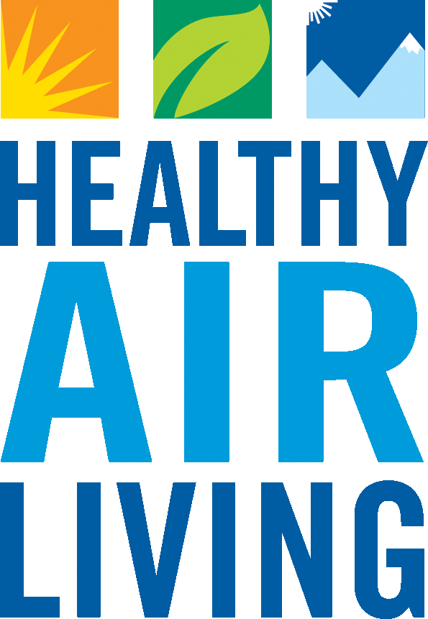San Joaquin Valley Air Pollution Control District

[www.valleyair.org](http://www.valleyair.org)

#### **Rule 3110 Small Business Certification**

***Please complete one form for each District Facility ID***

For facilities that meet the **Small Business** criteria as outlined below, the Rule 3110 (Air Toxics Fees) fees are capped at a flat rate of $300 per year. Note, facilities may already be subject to a lower fee based on another fee category in the rule.

|  |  |
| --- | --- |
| Facility Name: | District Facility ID #: |
| Facility Mailing Address: | |
| Facility Location Address: | |
| Title 17 of the California Code of Regulations Section 90704 provides for a cap on the total annual air toxic fees, including District and State fees, charged for small businesses. To qualify for the small business cap, a company official must complete and submit the following statement certifying the business meets **all** of the following criteria as specified in the regulation:   * I hereby certify that the facility named above is independently owned and operated. * I hereby certify that the facility named above had 10 or fewer (annual full-time equivalence) employees in the preceding year. * I hereby certify that the facility named above had total annual gross receipts of less than $1,000,000 in the preceding year. * I hereby certify that the total annual gross receipts for the California operations that the facility named above is part of, were less than $5,000,000 in the preceding year. | |
| Facility Contact Name (Print): | Facility Contact Phone #: |
| Facility Responsible Official Name (Print): | Title of Responsible Official: |
| Signature of Responsible Official: | Date: |

Please mail this form to:

Carol Flores - SJVAPCD

1990 E. Gettysburg Ave.

Fresno, CA 93726

Or

E-mail to: [hotspots@valleyair.org](mailto:hotspots@valleyair.org)